Name: __________________________________ Section: ______ Marked By: __________________________________

**DBAS 1007** - **Tech Check #5**

SELECT Queries with JOINs & Aggregates



**Value:** 4% of overall course mark

**Time to complete:** 45 Minutes

10

**Instructions:**

Create a single SQL script file that includes your SQL Select statement solutions to the following queries. When complete, upload your submission to the Tech Check 5 dropbox on Brightspace.

**Using the Sakila Database:**

|  |
| --- |
| **Query 1.**  Write a query that returns the film ID, title and language for all films with a rating of PG-13. Rename columns as indicated. (2 pts)  **Yes _______ No _______ Partial _______** |
| **Query 2.**  Write a query that displays the CustomerID and total amount of all payments that customer 47 made for movies they rented in the month of August. Rename columns as indicated. (Hint: Month() function) (2 pts)  **Yes _______ No _______ Partial _______** |
| **Query 3.**  Write a query that returns the number of payments received by each staff member. Display the staff ID and last name, and how many payments they received. Rename columns as indicated.  (2 pts)  **Yes _______ No _______ Partial _______** |
| **Query 4.**  Write a query that displays a list of each actor, movie name and movie category for all movies with a category of Animation. Sort by actor last name and movie title. Rename columns as indicated.  (2 pts)  **Yes _______ No _______ Partial _______** |
| **Query 5.**  Write a query to display the first and last names (in a single field), the address, city and country for all customers from Germany. Sort by city in reverse alphabetical order. Rename columns as indicated.  (2 pts)  **Yes _______ No _______ Partial _______** |

**Expected Results**

Query 1 - (223 records, first 10 shown)

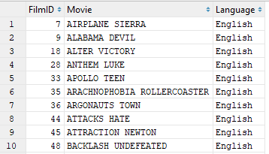

Query 2 - (1 record)



Query 3 - (2 records)

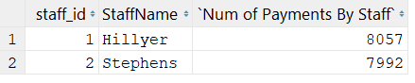

Query 4 - (361 records, first 10 shown)

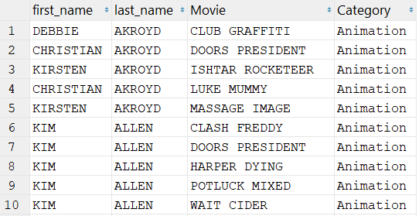

Query 5 - (7 records)

